Project chosen: Topic 12 – Implement a blackjack simulation

Group members: Nathan Kistler

The game of blackjack is a simple game where the goal is to beat the dealer by getting a card count close to 21 without going over 21. A game starts by each player and the dealer being dealt two cards. The dealer reveals one of their cards allowing each player to make an educated decision as to hit (request another card) or stay. The basic strategy of blackjack is to only request a new card if the total of a player’s cards is less than 17. There are more advanced concepts such as splitting cards when dealt a pair or adjusting the bet depending on the cards dealt. A list of several of these strategies can be found at the following link (<https://www.888casino.com/blog/blackjack-strategy/best-blackjack-strategies>).

For the current project I decided to code the simulation in Python. This was due to my comfort with the coding language and the available packages that would be useful for the problem at hand. For instance, numpy, matplotlib, and random have been used in the current version of the simulation. The work completed to date was to create a simulation of the most basic blackjack strategy (i.e., hitting until reaching 17). The work is compiled in a GIT repository (<https://github.com/natekist/GT-OMS/tree/main/IYSE%206644/Project/Group%2022%20-%20Blackjack>). The results are shown in the image below where the x-axis is the number of games simulated and the y-axis is the percentage of games won. As expected, the results are variable when the simulated number of games are low. The results hit a steady state ~42% as the number of simulated games increase. These results are consistent with the reported odds of winning at blackjack (<https://www.mrgreen.com/en/blackjack/strategies/blackjack-odds>).

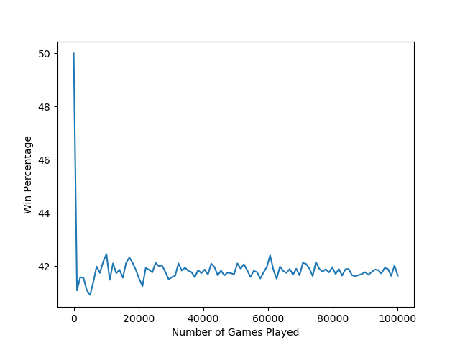

The next steps for the project are to introduce the additional strategies mentioned above. The win percentage after introducing the strategies will be compared to identify if using more advanced strategies will improve a player’s chance of winning.